- File handling:
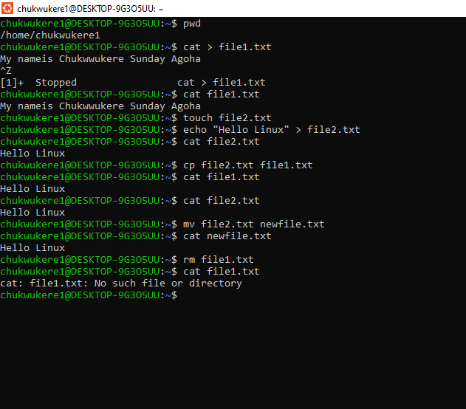

• touch file1.txt → Create an empty file
• cat > file1.txt → Create a new file
• echo "Hello Linux" > file1.txt → Write text into a file
• cat file1.txt → Display file contents
• cp file1.txt file2.txt → Copy a file
• mv file2.txt newfile.txt → Rename/move a file
• rm newfile.txt → Delete a file

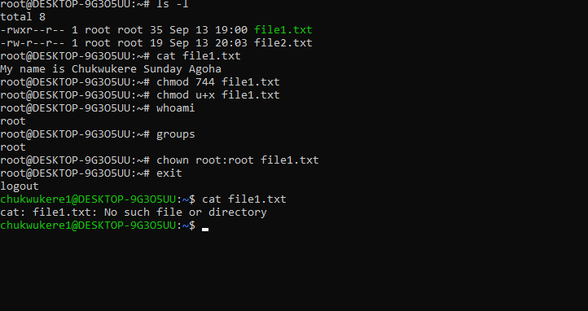
B. Directory Management

• mkdir testdir → Create a new directory
• cd testdir → Move into the directory
• pwd → Show current working directory
• ls → List contents of the directory
• rmdir testdir → Remove an empty directory

C. Permissions
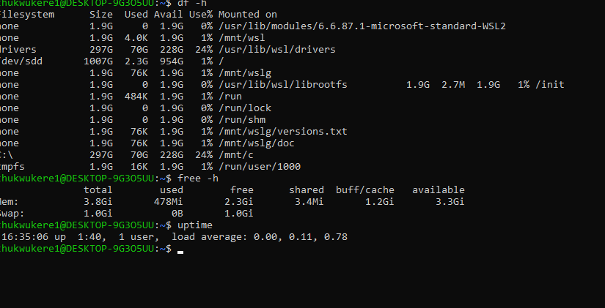
• ls -l → Check file permissions
• chmod 744 file1.txt → Change permissions (owner read/write/execute, group read, others read)
• chmod u+x file1.txt → Add execute permission to the owner
• chown user:group file1.txt → Change ownership

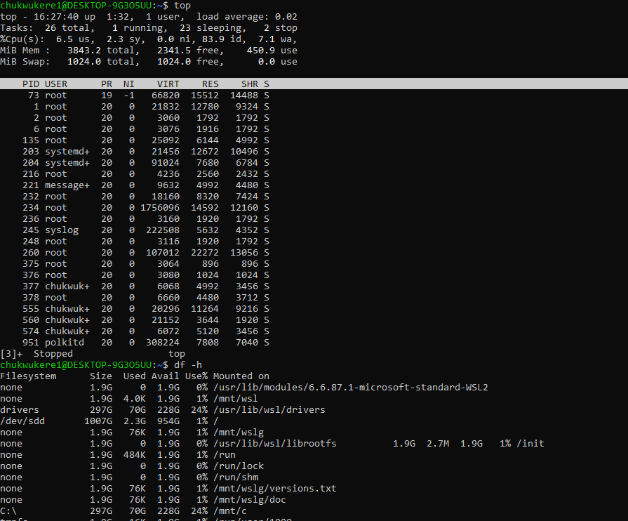
D. Simple System Monitoring

• top → Display real-time running processes
• htop (if installed) → User-friendly process viewer
• df -h → Show disk space usage
• free -h → Display memory usage
• uptime → Show how long the system has been running

